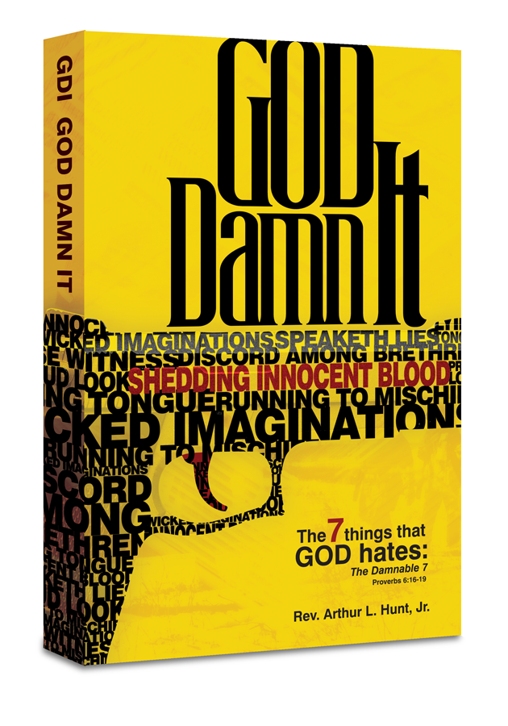
FOR IMMEDIATE RELEASE
Contact: Rev. Arthur L. Hunt, Jr. | The College of Aspiring Artists | 870.623.8179 ceo@thecollegeofaspiringartists.education
GOD DAMN IT New Book Release and Tour Comes With Urgent Message Speaking to the 7 Damnable Things That God Hates— Pronouncing What God Damns in the USA

Sunday, April 9, 2023, Dumas, Arkansas – From the publishers of the MLK50 Commemorative Bible with a new co-publishing international partner comes the first book in a bold message and title, “GDI… GOD DAMN IT.” GDI…GOD DAMN IT, speaks to the 7 things that God hates as outlined in the book of Proverbs, chapter 6, verses 16—19: a proud look, a lying tongue, hands that shed innocent blood, a heart that devises wicked imaginations, feet that be swift running into mischief, a false witness that speaks lies and one who sows discord among brethren. The author, Rev. Arthur L. Hunt, Jr., says, “When a six-year-old goes to school to kill for thrills, when our nation is indicting a former U.S. President, etc., we have no choice but to say… GDI, God Damn it, and it’s time to mitigate these 7 damnable sins.”
While the book release is set for three phases May—June 2023, the announcement comes in tribute to the 55th Anniversary of Rev. Dr. King’s final prophecy and assassination April 3—4, 1968, and providentially coincides with three religious Holidays: Ramadan, Passover, and Easter. It critically comes when mass shootings and gun violence are at all time highs. It comes when God’s storms of wind and wrath are raging. The book chronicles 33 years from 1990—2023, and new movement, the TN Three.
The book looks at the hate in the nation and the outbreaks of violence from schools to houses of worship, etc., due to the disregard and often dismissal of the 7 things that God hates. It provides antidotes and a strategic guide that bring a nation and a world back to God.
The launch of GDI…GOD DAMN IT conveys to the multiple groups of people and institutions of politics, media, religious denominations, families, etc., God Damn It, when either one or combination of the 7 things that God hates is operative. The book explores the word ‘hate’ and the world of hate, which is strong language from the God who is universally known as the God of Love and the God who is Love.
For more on the launch visit www.goddamnit.today

